
Measuring what matters: tracking climate adaptation processes and outcomes for smallholder producers in the agriculture sector

Deliverable 5: Systematic Map

June 2026, v01

Jennifer Denno Cissé*, jenn@bristlep.com, USA, Bristlepine Resilience Consultants
Zarrar Khan, zarrar@bristlep.com, USA, Bristlepine Resilience Consultants
Caroline G. Staub, caroline@bristlep.com, USA, Bristlepine Resilience Consultants

Keywords: Climate Adaptation, Adaptation Outcomes, Adaptation Process, Smallholder Farmers, Monitoring and Evaluation (M&E), Agriculture

1. Key findings
This document presents a systematic map of methods used to track and measure climate adaptation processes and outcomes for smallholder producers in LMICs. This report is based on 86 studies coded across five batches (those included after full-text screening of a randomly selected 100 papers), but additional researcher-led coding is ongoing. Seven findings stand out:
- Rigorous experimental approaches (like randomized control trials) and modeling with empirical validation are exceptionally rare: Only 6% of coded studies use experimental designs. Quantitative and qualitative methods dominate. The evidence base can describe what was implemented but cannot prove whether it improved outcomes.
- Few studies measured wellbeing outcomes: Measure of health and nutrition, as well as subjective wellbeing, is the least studied outcome in the evidence base.
- Producer bias: Adaptation research overwhelmingly targets crop farmers. Fisheries/aquaculture and agroforestry account for just 7% of producer-type tags combined. These producer systems, critical across tropical LMICs, are nearly invisible in the evidence base.
- Institutional governance appears in only 10 study-domain instances across all producer types: The systemic conditions that determine whether adaptation reaches people are almost entirely unmeasured. Access to services appears in only 17 instances.
- Highly vulnerable groups remain largely underrepresented in the literature: 40% of coded studies do not specifically target marginalized groups. Where they do, it is mostly women, indigenous peoples and youth. Disability, ethnic minorities, and the elderly appear in 4 or fewer studies each.
- Process over outcomes: Knowledge, adoption, and decision-making account for the majority of the evidence base. Income, wellbeing, resilience, and other impact outcomes are substantially underrepresented by comparison.
- Studies are heavily concentrated in Sub-Saharan Africa and South Asia. Ethiopia, Ghana, and Kenya alone account for 28% of all human-coded studies. Large evidence gaps persist across Central America, Southeast Asia, the Sahel, and MENA.

2. Background
A growing number of climate adaptation interventions and autonomous adaptation are being deployed across the agriculture sector to support smallholder producers in LMICs. Despite growing investment, a central challenge persists: how to measure the effectiveness of these interventions. Monitoring and evaluation (M&E) in this space is particularly complex, due to long timeframes, evolving climate baselines, terminological differences, and attribution challenges. This systematic map responds to these challenges by systematically identifying, and characterising the methods used to assess climate adaptation interventions in the agriculture sector, with a focus on smallholder producers in LMICs.

3. Methods
A brief summary of methods is provided here. More detail can be found in the systematic map protocol.

3.1 Search Strategy
Searches were conducted in Scopus (Elsevier) in January 2026, using a structured Boolean search string developed around the PCCM framework (Population: smallholder producers; Concept: adaptation processes and outcomes; Context: climate hazards, LMICs, agriculture sector; Methodological Focus: measurement, indicators, monitoring and evaluation approaches). Searches were restricted to literature published from 2005 onward and to English, French, and Spanish language sources. A total of 17,021 records were retrieved.
Additional databases searched in parallel include Web of Science Core Collection, CAB Abstracts, Academic Search Premier, EconLit, ProQuest, Google Scholar, and AGRIS. Grey literature sources (approximately 20 repositories) were also searched. Across all sources, 40,653 records were retrieved prior to deduplication. Abstract screening, full-text retrieval, and data extraction for these databases are now complete on a randomly selected subset of studies included for full-text screening.

3.2 Deduplication
Records from all databases were deduplicated using a multi-stage matching algorithm: exact DOI match, then exact title and year match, then fuzzy title similarity (Jaccard ≥ 0.85). Scopus records were used as the primary reference set; net-new records from other databases were identified against this base.

3.3 Screening
Title and abstract screening was conducted using a validated LLM-assisted screening tool (Ollama/qwen2.5:14b), calibrated against the PCCM eligibility criteria. Two calibration rounds were completed prior to full-corpus screening, achieving a sensitivity of 0.966–0.970 against human-coded benchmarks. All 26,173 deduplicated records were screened at the title and abstract stage. Of these, 8,753 (33%) were included for full-text assessment and 17,420 (67%) were excluded.

3.4 Coding and information saturation
Data extraction used a random sampling approach. Of the papers included for full-text screening, studies were drawn in batches of 20 (fixed integer seeds 42–46; each batch excludes prior-batch DOIs). Coders applied the five PCCM inclusion criteria to confirm inclusion, then completed 16 extraction fields (country, scale, producer type, adaptation focus, domain, methodology, equity, etc.).
Information saturation was tracked at each batch across three dimensions: process/outcome domains (13 canonical values), methodological approaches (5), and producer types (5). All three dimensions reached saturation within the initial few batches (49 papers coded) with zero new canonical categories added across the final two batches (37 additional papers). Across five batches, 100 papers were drawn for coding; 86 met the inclusion criteria. Additional batches that are already being processed will be included in the study even though saturation has already been reached.

4. Final results

4.1 Search and screening summary
A total of 40,653 records were identified across eight bibliographic databases and 20 grey literature sources. After deduplication, 26,173 unique records entered title and abstract screening. The validated LLM screening tool identified 8,753 records for full-text assessment. Papers were coded in batches of 20 by research assistants. Of 100 papers drawn across five batches, 86 met the inclusion criteria; additional batches are in process.
Table 1. Search and screening results by database
Database | Returned | After dedup | Abstr. incl.
Scopus | 17,021 | 17,021 | 6,218
Web of Science | 15,179 | 4,683 | 1,137
CAB Abstracts | 5,723 | 3,229 | 1,133
Academic Search Premier | 1,187 | 274 | 66
AGRIS | 3 | 1 | 1
EconLit | 479 | 263 | 83
ProQuest | 368 | 117 | 40
Google Scholar | 198 | 100 | 34
Grey literature (20 sources) | 495 | 485 | 41
Total | 40,653 | 26,173 | 8,753

Figure 1 presents the PRISMA flow diagram showing record flow across 28 sources and all screening stages.
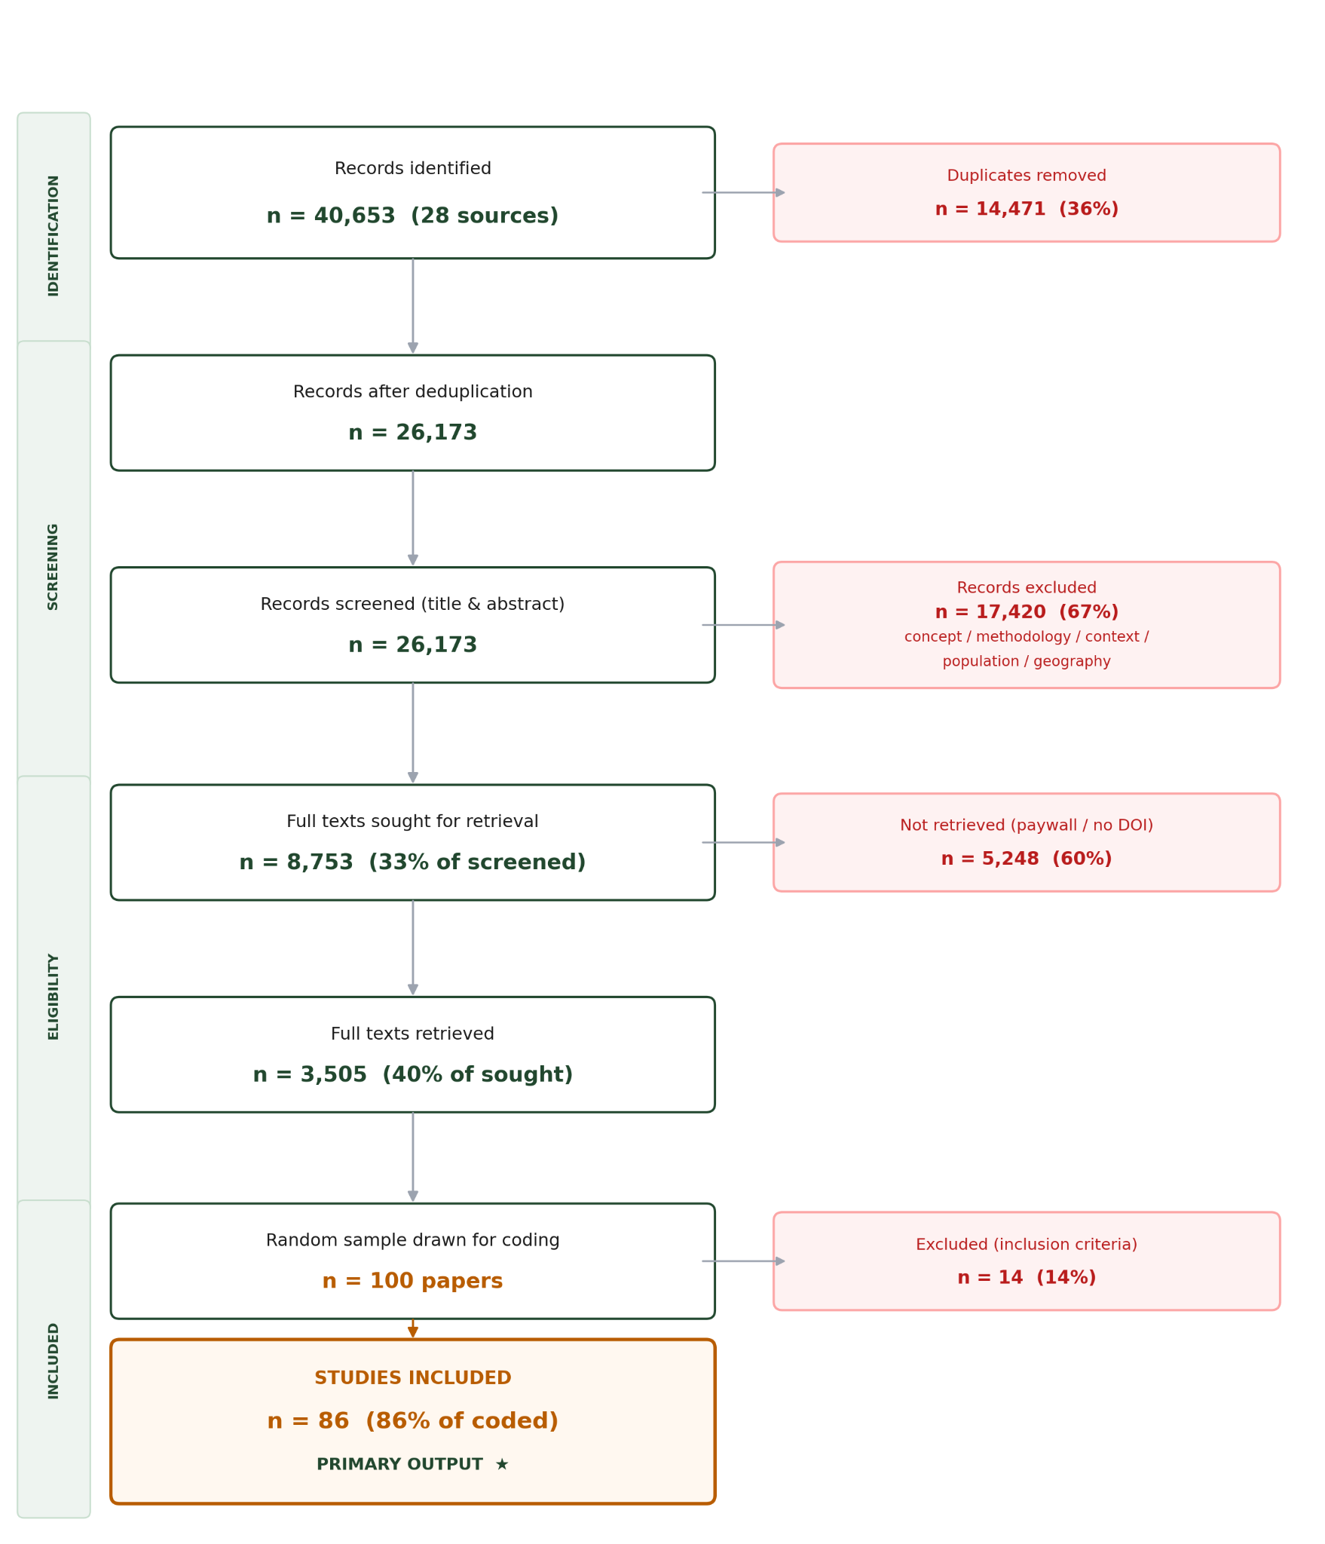
Figure 1. PRISMA flow diagram — record flow across 28 sources.

4.2 Evidence gap map
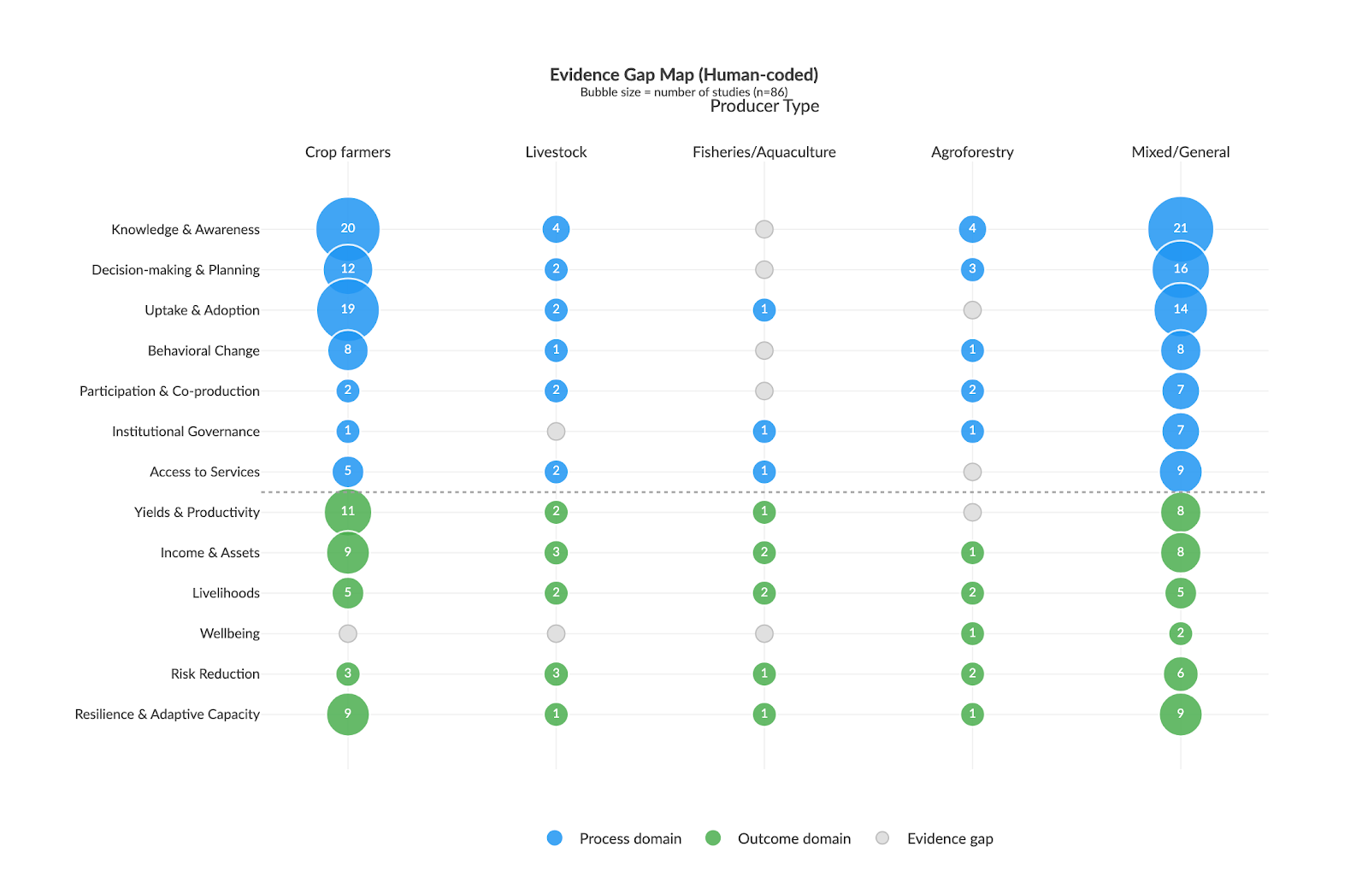
The evidence gap map (EGM) is the primary output of this deliverable. It plots the distribution of coded studies (n = 86) across process and outcome domains (y-axis) and producer types (x-axis). Bubble size is proportional to the number of studies in each cell. Grey circles indicate evidence gaps — no studies in that combination.
Figure 2. Evidence gap map results (n = 86). Blue = process domains · green = outcome domains · grey = evidence gaps. Bubble area ∝ number of studies.
Key observations:
- Process-oriented measures dominate. Decision-making & planning, knowledge & awareness, and uptake & adoption are the most studied domains, especially for crop farmers.
- Outcome-oriented measures are nearly absent. Income & assets, wellbeing, risk reduction, and resilience are sparsely covered — and almost exclusively for crop systems.The evidence gap map statistically visualizes this limitation, showing a clustered abundance of research on whether crop farmers are trying to adapt, but limited evidence on whether these efforts are actually improving their long-term adaptive capacity and wellbeing.
- Over-representation of Crop Farmers. Non-crop producer types are systematically uncovered. Livestock, fisheries, agroforestry, and mixed-system producers appear in very few cells; most cells for these types are gaps.
- Institutional governance and access to services are absent across all producer types.

4.3 Geographic distribution
Studies are heavily concentrated in Sub-Saharan Africa and South Asia. Ethiopia, Ghana, and Kenya alone account for 28% of all human-coded studies. Large evidence gaps persist across Central America, Southeast Asia, the Sahel, and MENA.

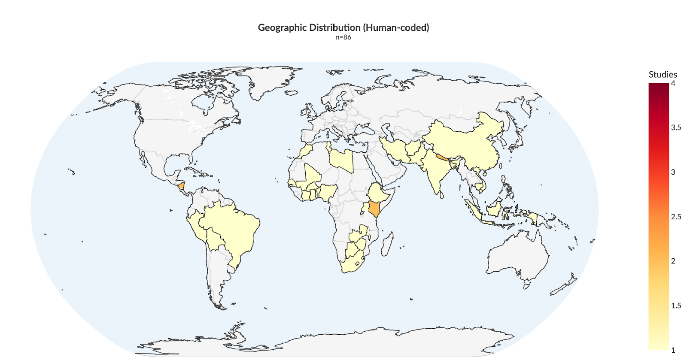
Figure 3. Geographic distribution of included studies (human-coded, n = 86).

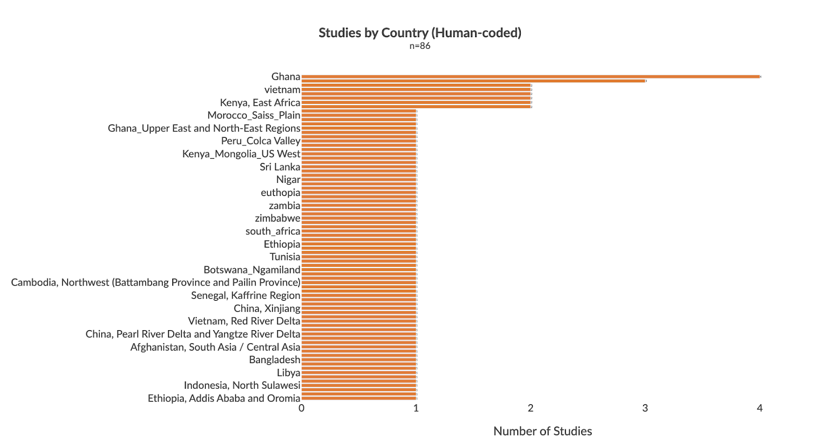
Figure 4. Top countries by study count (human-coded, n = 86).

4.4 Methodological approaches
Quantitative (Survey-based) and qualitative approaches dominate the evidence base. Experimental designs — including randomised controlled trials and quasi-experimental studies — represent fewer than 10% of the corpus, severely limiting causal inference about adaptation effectiveness. Participatory and mixed-methods approaches are common, particularly for process-level outcomes. This heavy reliance on observational quantitative and qualitative approaches—and the near absence of experimental or longitudinal designs—means the current literature is very effective at mapping the uptake and awareness of adaptation strategies. However, it severely limits researchers' ability to definitively prove causality, avoid endogeneity bias, and objectively evaluate the long-term effectiveness of capacity-building interventions on actual farmer resilience.

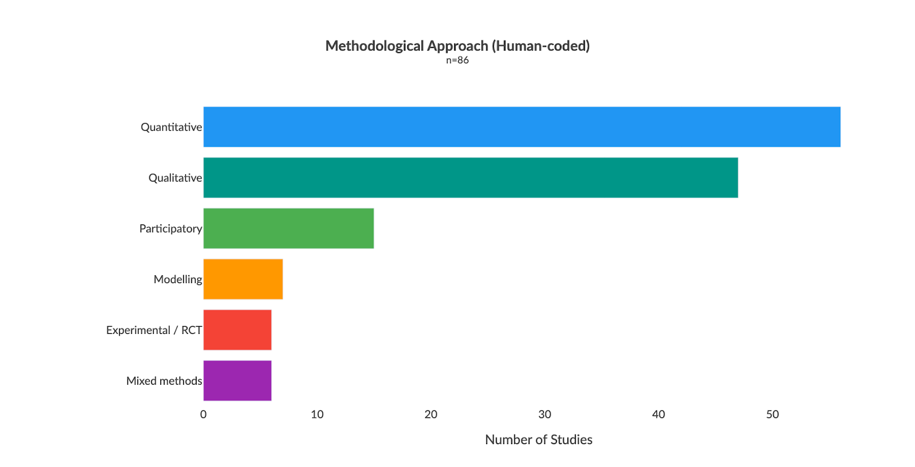Figure 5. Methodological approaches across included studies (human-coded, n = 86).

4.5 Equity and inclusion
There is a significant gap in how adaptation research addresses social vulnerability. 40% of included studies make no reference to any marginalized group. Where groups do appear, the focus is heavily skewed: women feature in ~35% of studies and youth in ~29%. Beyond these two groups, the evidence base drops sharply with indigenous peoples, landless communities, ethnic minorities, and migrant workers each appearing in fewer than 5% of studies, and people with disabilities and the elderly in fewer than 2%.
This concentration on women and youth, while valuable, masks the absence of evidence for other highly vulnerable populations. The literature largely treats smallholder farmers as a homogenous group, ignoring how intersecting vulnerabilities (disability, land tenure, ethnicity, age) shape an individual's capacity to adapt to climate shocks. Because studies rarely measure how specific subgroups respond to interventions, future climate resilience programmes risk relying on generic capacity-building models that overlook the distinct needs of the most marginalised.

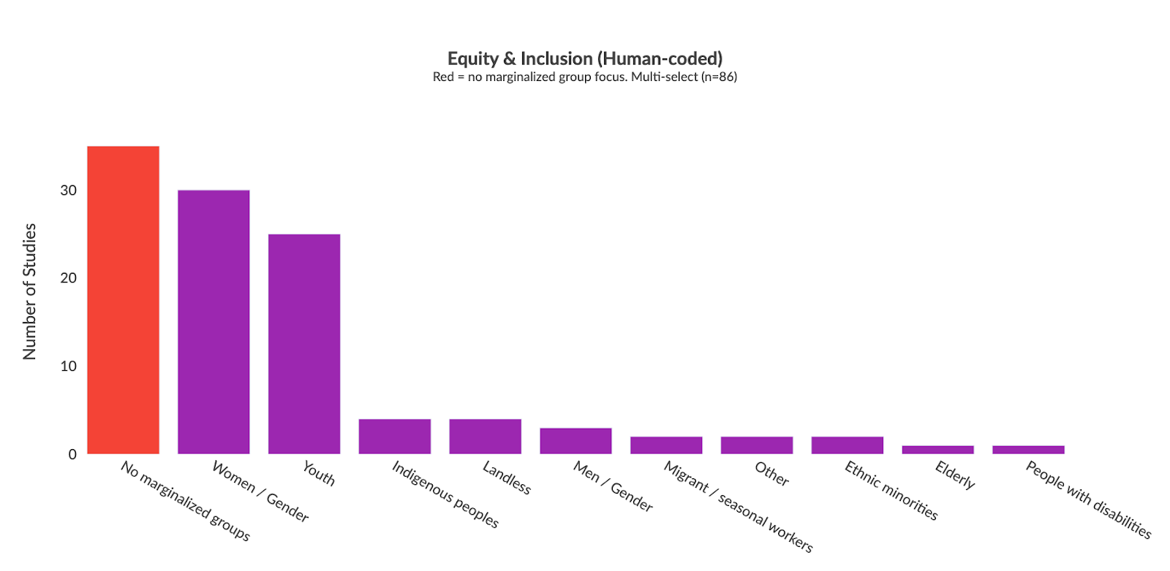
Figure 6. Equity and inclusion dimensions across included studies (human-coded, n = 86). Red bar = studies with no marginalized group focus.

4.6 Publication trends and saturation
96% of included studies were published since 2015, with a median year of 2022. Publication volume has grown sharply — but this means that long-term impact evidence is very thin..

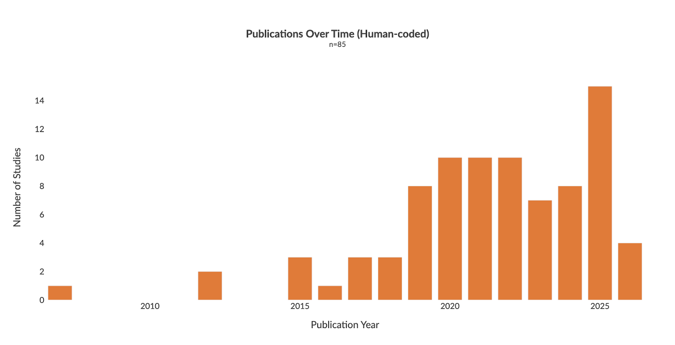
Figure 7. Publication trends across included studies (human-coded, n = 86).

Saturation analysis (Figure 8) shows that all three tracked dimensions — process/outcome domains, methodological approaches, and producer types — reached saturation by 49 papers. Zero new canonical categories were added in the final two batches, confirming the human-coded sample is representative of the broader evidence base.
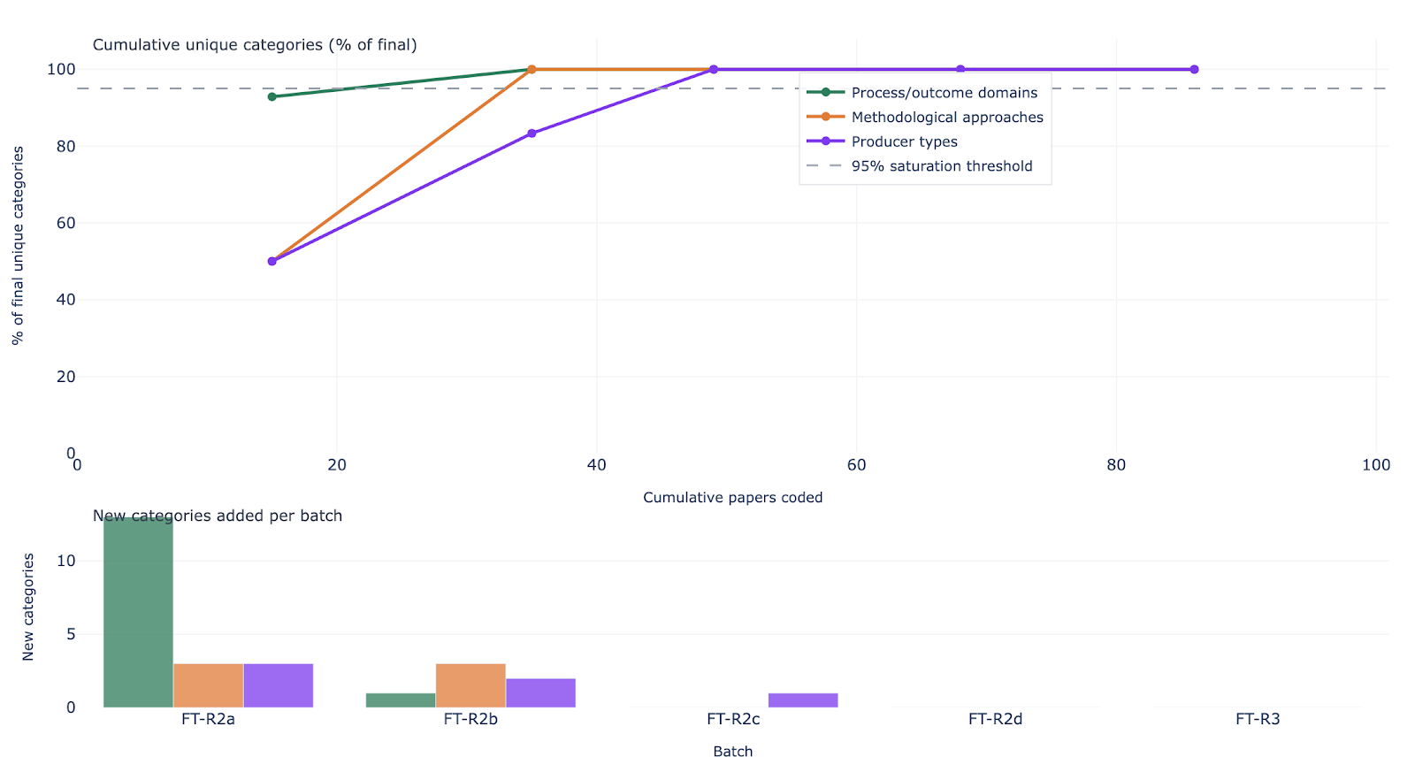Figure 8. Information saturation curve. Top: cumulative unique categories as % of final total by papers coded. Bottom: new categories per batch. All dimensions plateau by 49 papers.

5. Searchable Database
An interactive evidence gap map is available at https://main.d3a9jahzuu7xai.amplifyapp.com/systematic-map.
A searchable database of all included studies is available at https://main.d3a9jahzuu7xai.amplifyapp.com/systematic-map#searchable-database
The database includes all 2,368 LLM-screened records with key metadata (year, title, country, producer type, domain, methodology). A toggle switches between the human-coded results (n = 86, authoritative) and the LLM corpus (n = 2,368, exploratory). All code and data: github.com/bristlepine/ilri-climate-adaptation-effectiveness

6. Conclusions
The evidence gap map reveals a systematic mismatch between what adaptation M&E currently measures and what is needed to understand adaptation effectiveness.
- Process-oriented outcomes are well-documented, impact-oriented outcomes are not. The literature reliably captures whether farmers adopted a practice or gained knowledge. It almost never measures whether adaptation improved incomes, wellbeing, or resilience.
- Non-crop producer types are almost entirely unmeasured. Livestock, fisheries, agroforestry, and mixed-system producers appear in very few cells of the evidence map. Most are pure gaps.
- Geographic concentration limits generalisability. Three countries account for 28% of all studies. The evidence base cannot support regional conclusions across most LMICs.
- The equity gap is the most critical for policy. 40% of studies make no reference to any marginalized group; of the 60% that do, coverage is almost entirely limited to women and youth. Disability, ethnicity, age, and land tenure appear in 5% or fewer of studies each. We cannot tell whether adaptation is reaching the most vulnerable populations.
- A lack of robust experimental evidence limits causal inference. While cross-sectional quantitative and qualitative methods are abundant, rigorous experimental designs are exceptionally rare. This makes it difficult to definitively prove whether specific capacity-building or adaptation interventions actually cause improvements in long-term resilience, rather than merely showing correlations with practice adoption.
Addressing these gaps requires investment in long-term cohort studies, equity-disaggregated data collection, and research that targets non-crop livelihood systems. A follow-on systematic review and meta-analysis protocol is planned.

7. Acknowledgements
This work was funded by the International Livestock Research Institute (ILRI) under the CGIAR Initiative on Climate Resilience (ClimBeR). The authors thank the ILRI project team for their guidance and stakeholder engagement support throughout the protocol development and screening process. The systematic map protocol was peer-reviewed by an independent Methods Advisor and informed by feedback from the CGIAR and ILRI stakeholder network.

8. References
- Bristlepine Resilience Consultants (2026). Deliverable 3: Final Systematic Map Protocol — Measuring what matters: tracking climate adaptation processes and outcomes for smallholder producers in the agriculture sector. January 2026, v3. Zenodo. https://doi.org/10.5281/zenodo.19811629
- Collaboration for Environmental Evidence (2018). Guidelines and Standards for Evidence Synthesis in Environmental Management. Version 5.1. Pullin AS, Frampton GK, Livoreil B, Petrokofsky G (eds). https://www.environmentalevidence.org/guidelines
- Haddaway, N.R., Macura, B., Whaley, P. and Pullin, A.S. (2018). ROSES Reporting standards for Systematic Evidence Syntheses: pro forma, flow diagram and descriptive summary of the plan and conduct of environmental systematic reviews and systematic maps. Environmental Evidence, 7, 7. https://doi.org/10.1186/s13750-018-0121-7

